**Mini Project 1**

**Congratulations! You are one month into this course and have reached mini project 1!**

**When done, submit the GitHub website link to your repository in the Mini Project 1 assignment in Google Classroom**

Set up the project structure: Create a new folder for your project and organize your files. Remember good practice!

Obtain the background image: Download the provided background image.”bground.avif”

Create the HTML structure: Write the HTML code for the login page. Start with the basic structure, including the <!DOCTYPE html> declaration, <html> element, <head> section, and <body> section.

Add the background image: Use CSS to set the background image for the entire page. You can use the background-image property and specify the path to the image.

Build the header: Add a <header> element at the top of the page to welcome the user

Create the navigation bar: Build a navigation bar with the specified buttons and dropdown menu. Use HTML <nav> and <ul> elements to structure the navigation, and style it using CSS. You can use CSS to float the buttons and align them as required.

Design the login form: Create an HTML form that includes input fields for username, password, and gender, along with the login button and registration link. You can use appropriate <input> elements, <label> elements for captions, and <a> elements for the registration link.

Style the login form: Apply CSS styles to the login form, including a slightly darkened background to differentiate it from the rest of the page. Use CSS classes or IDs to target specific elements and apply the desired styles.

Add disclaimers: Include any necessary disclaimers or additional information within the login form. This can be done using HTML <p> elements or other appropriate tags.\

Test and refine: Test the page in different browsers and devices to ensure it looks and functions correctly. Make any necessary adjustments based on your testing.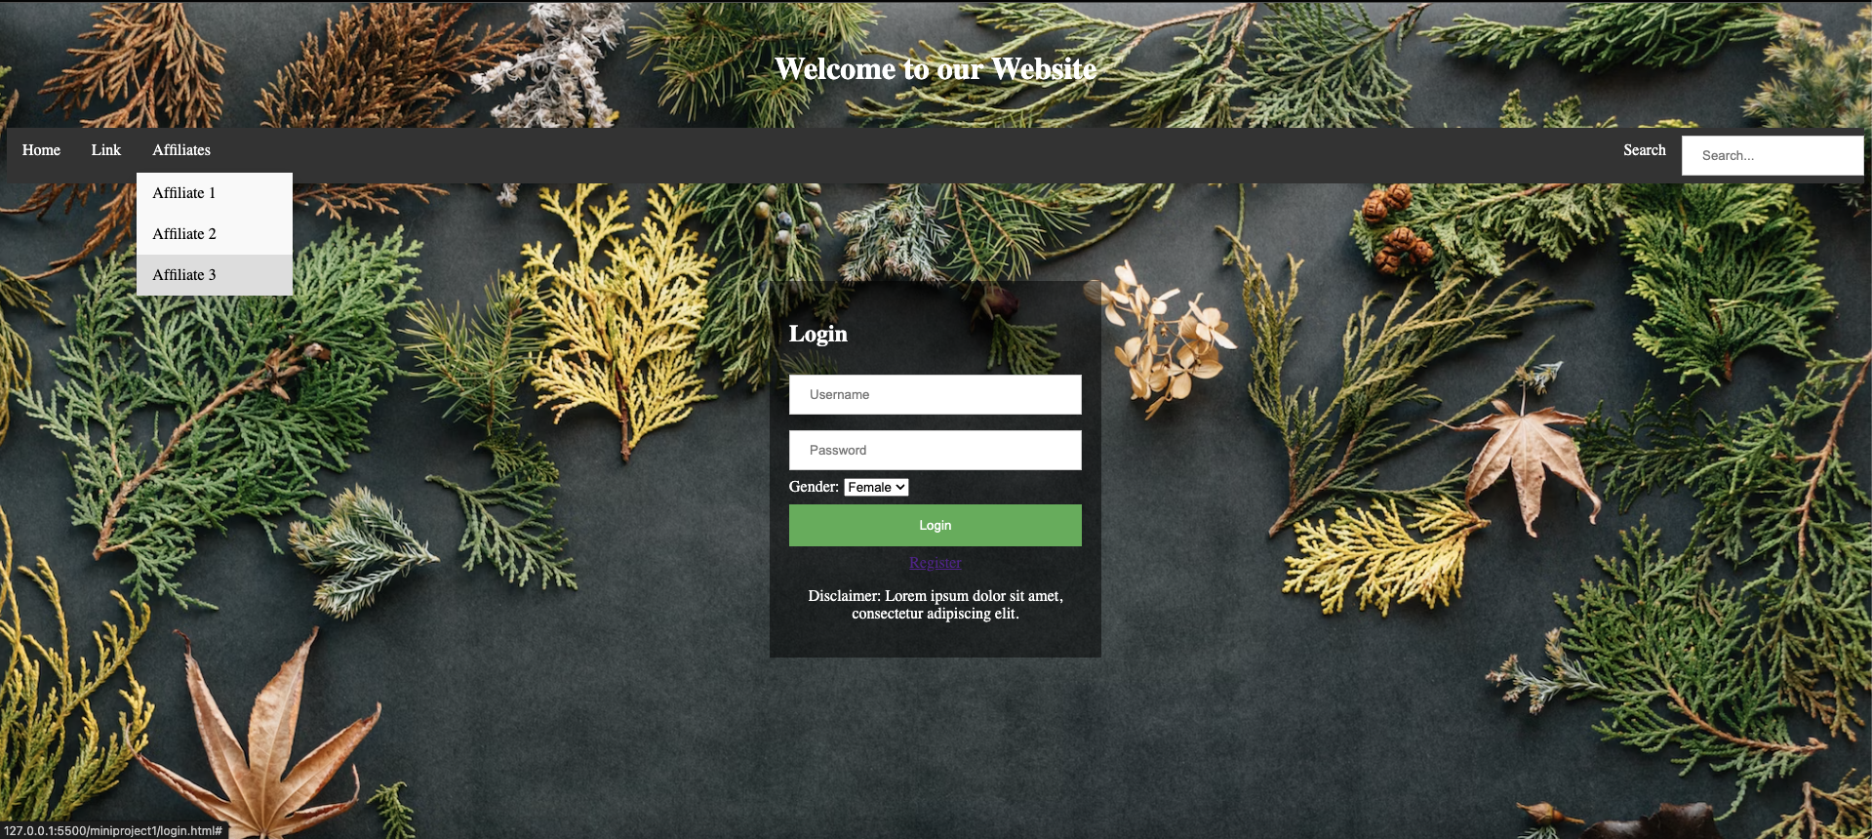

This should be your final result. ( file: mp1.png)